WUDL Sample Flow Series: Novice

This is a flow from a round between Oakton High School (VA) and Cathedral Prep High School (PA) from the regional tournament held at Georgetown Day School in September this season.

This round was included in our series to provide an example of how running multiple off case positions can function in a debate.

The affirmative ran a case about reforming the way that we teach Sex Ed—removing the abstinence only requirements and requiring a more inclusive discussion of gender identity in the course. They claim advantages based off health, combatting rape culture, and improving rights for women and the LGBTQ community.

The negative ran an array of off case positions, including a States Counterplan, a Federalism Disadvantage, an electoral politics Disadvantage and a legislative politics Disadvantage.

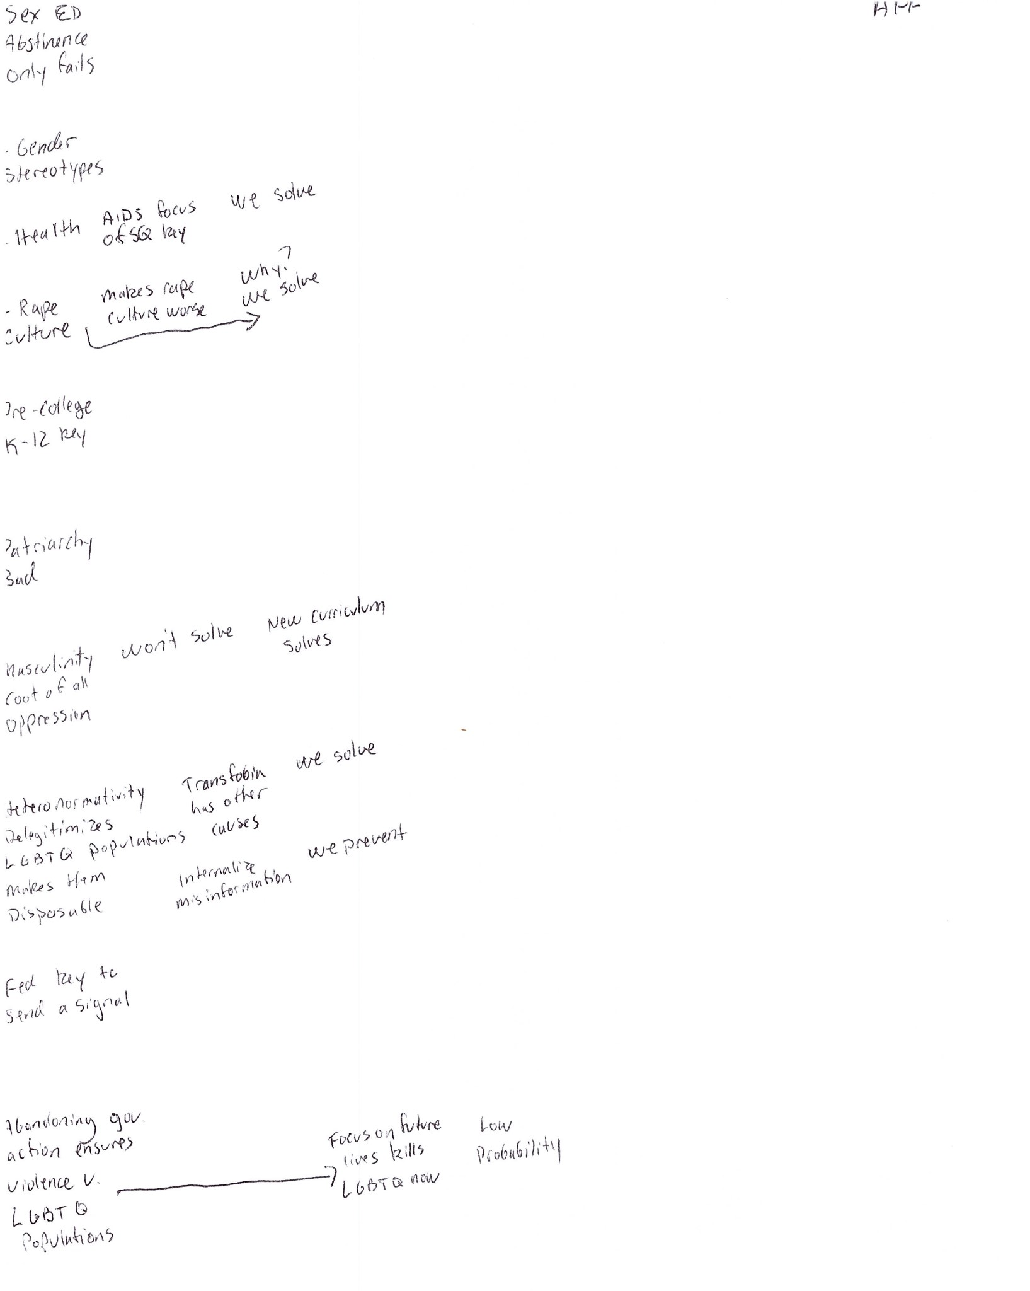

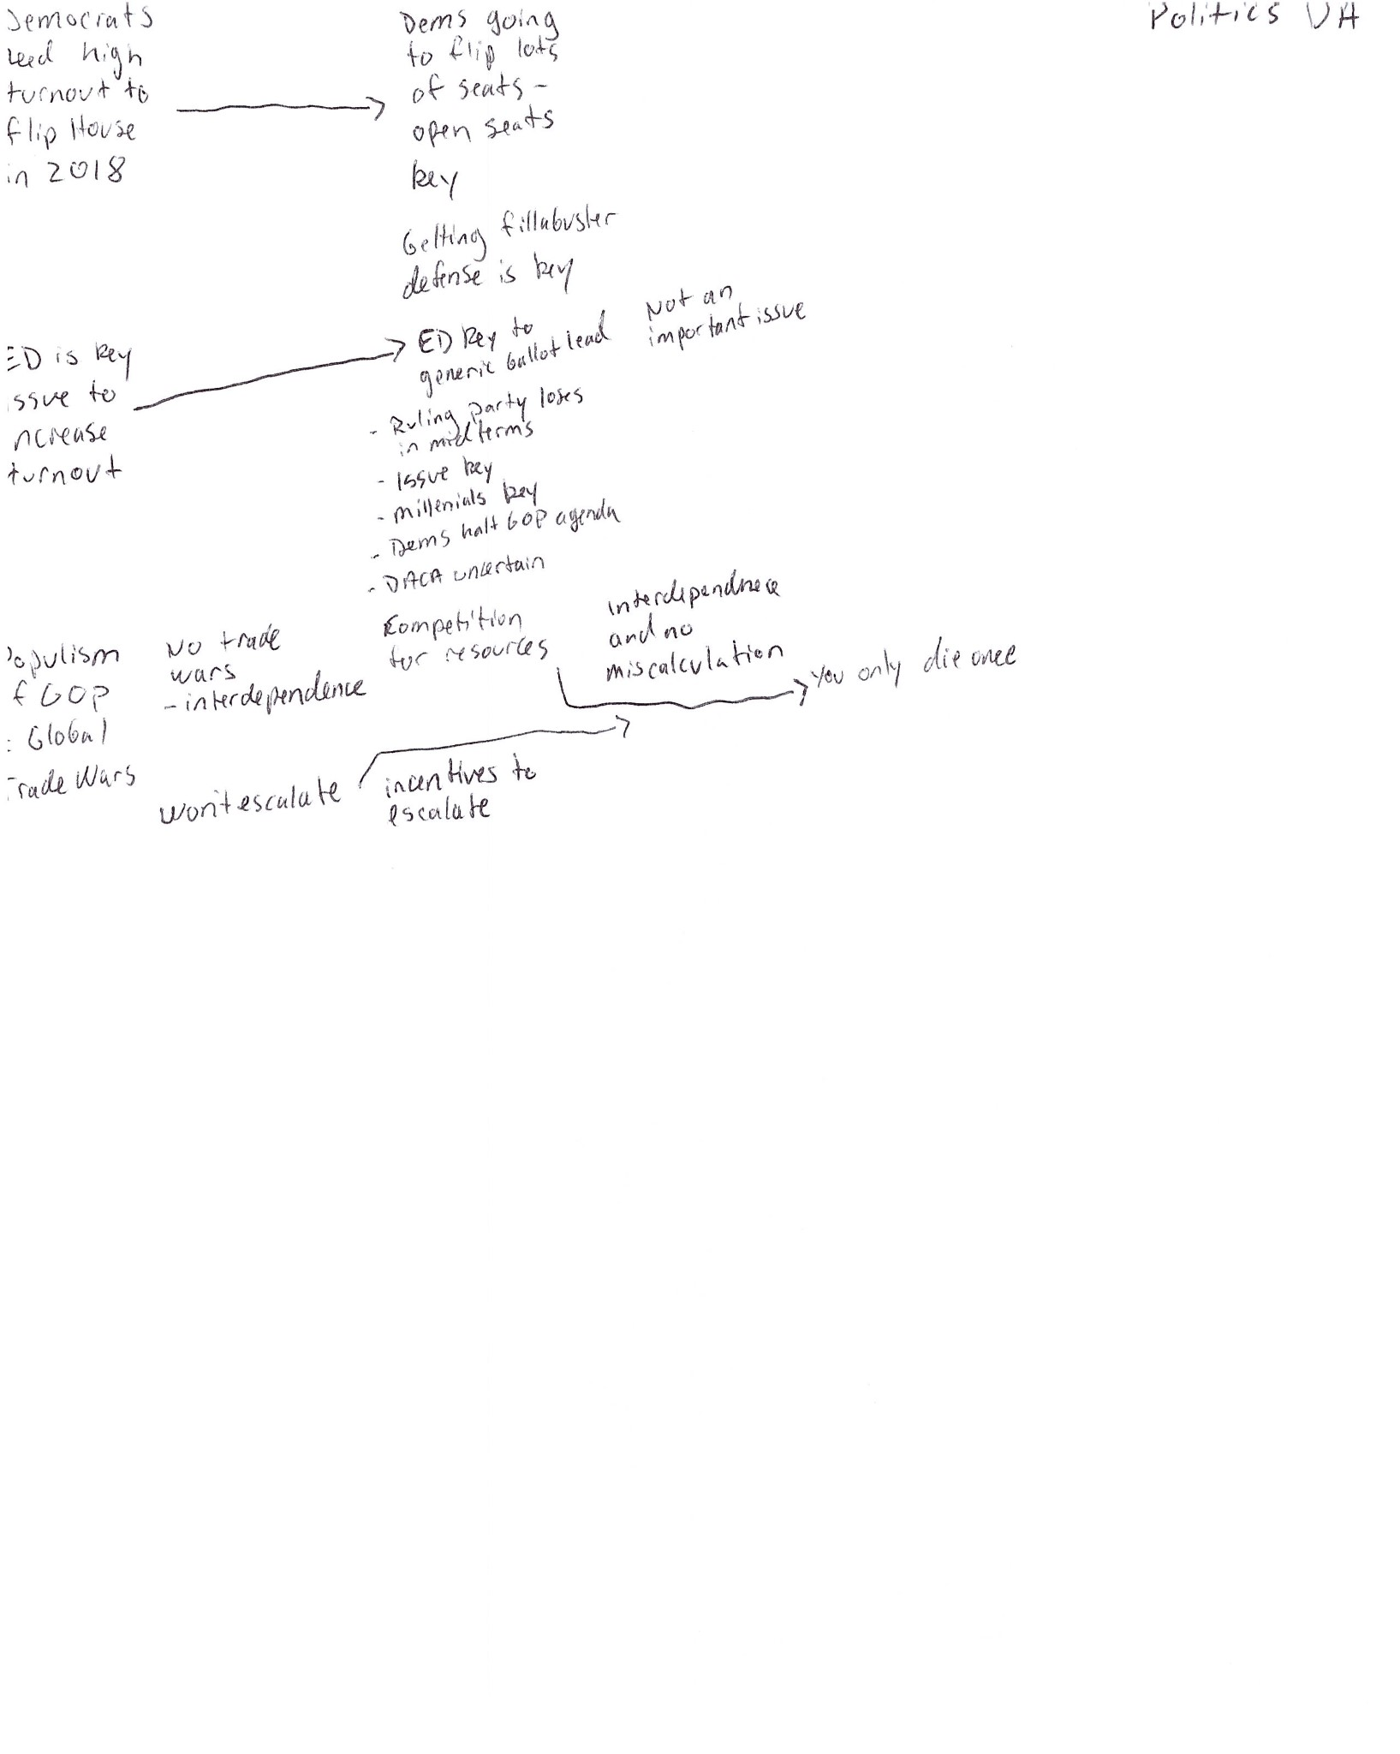

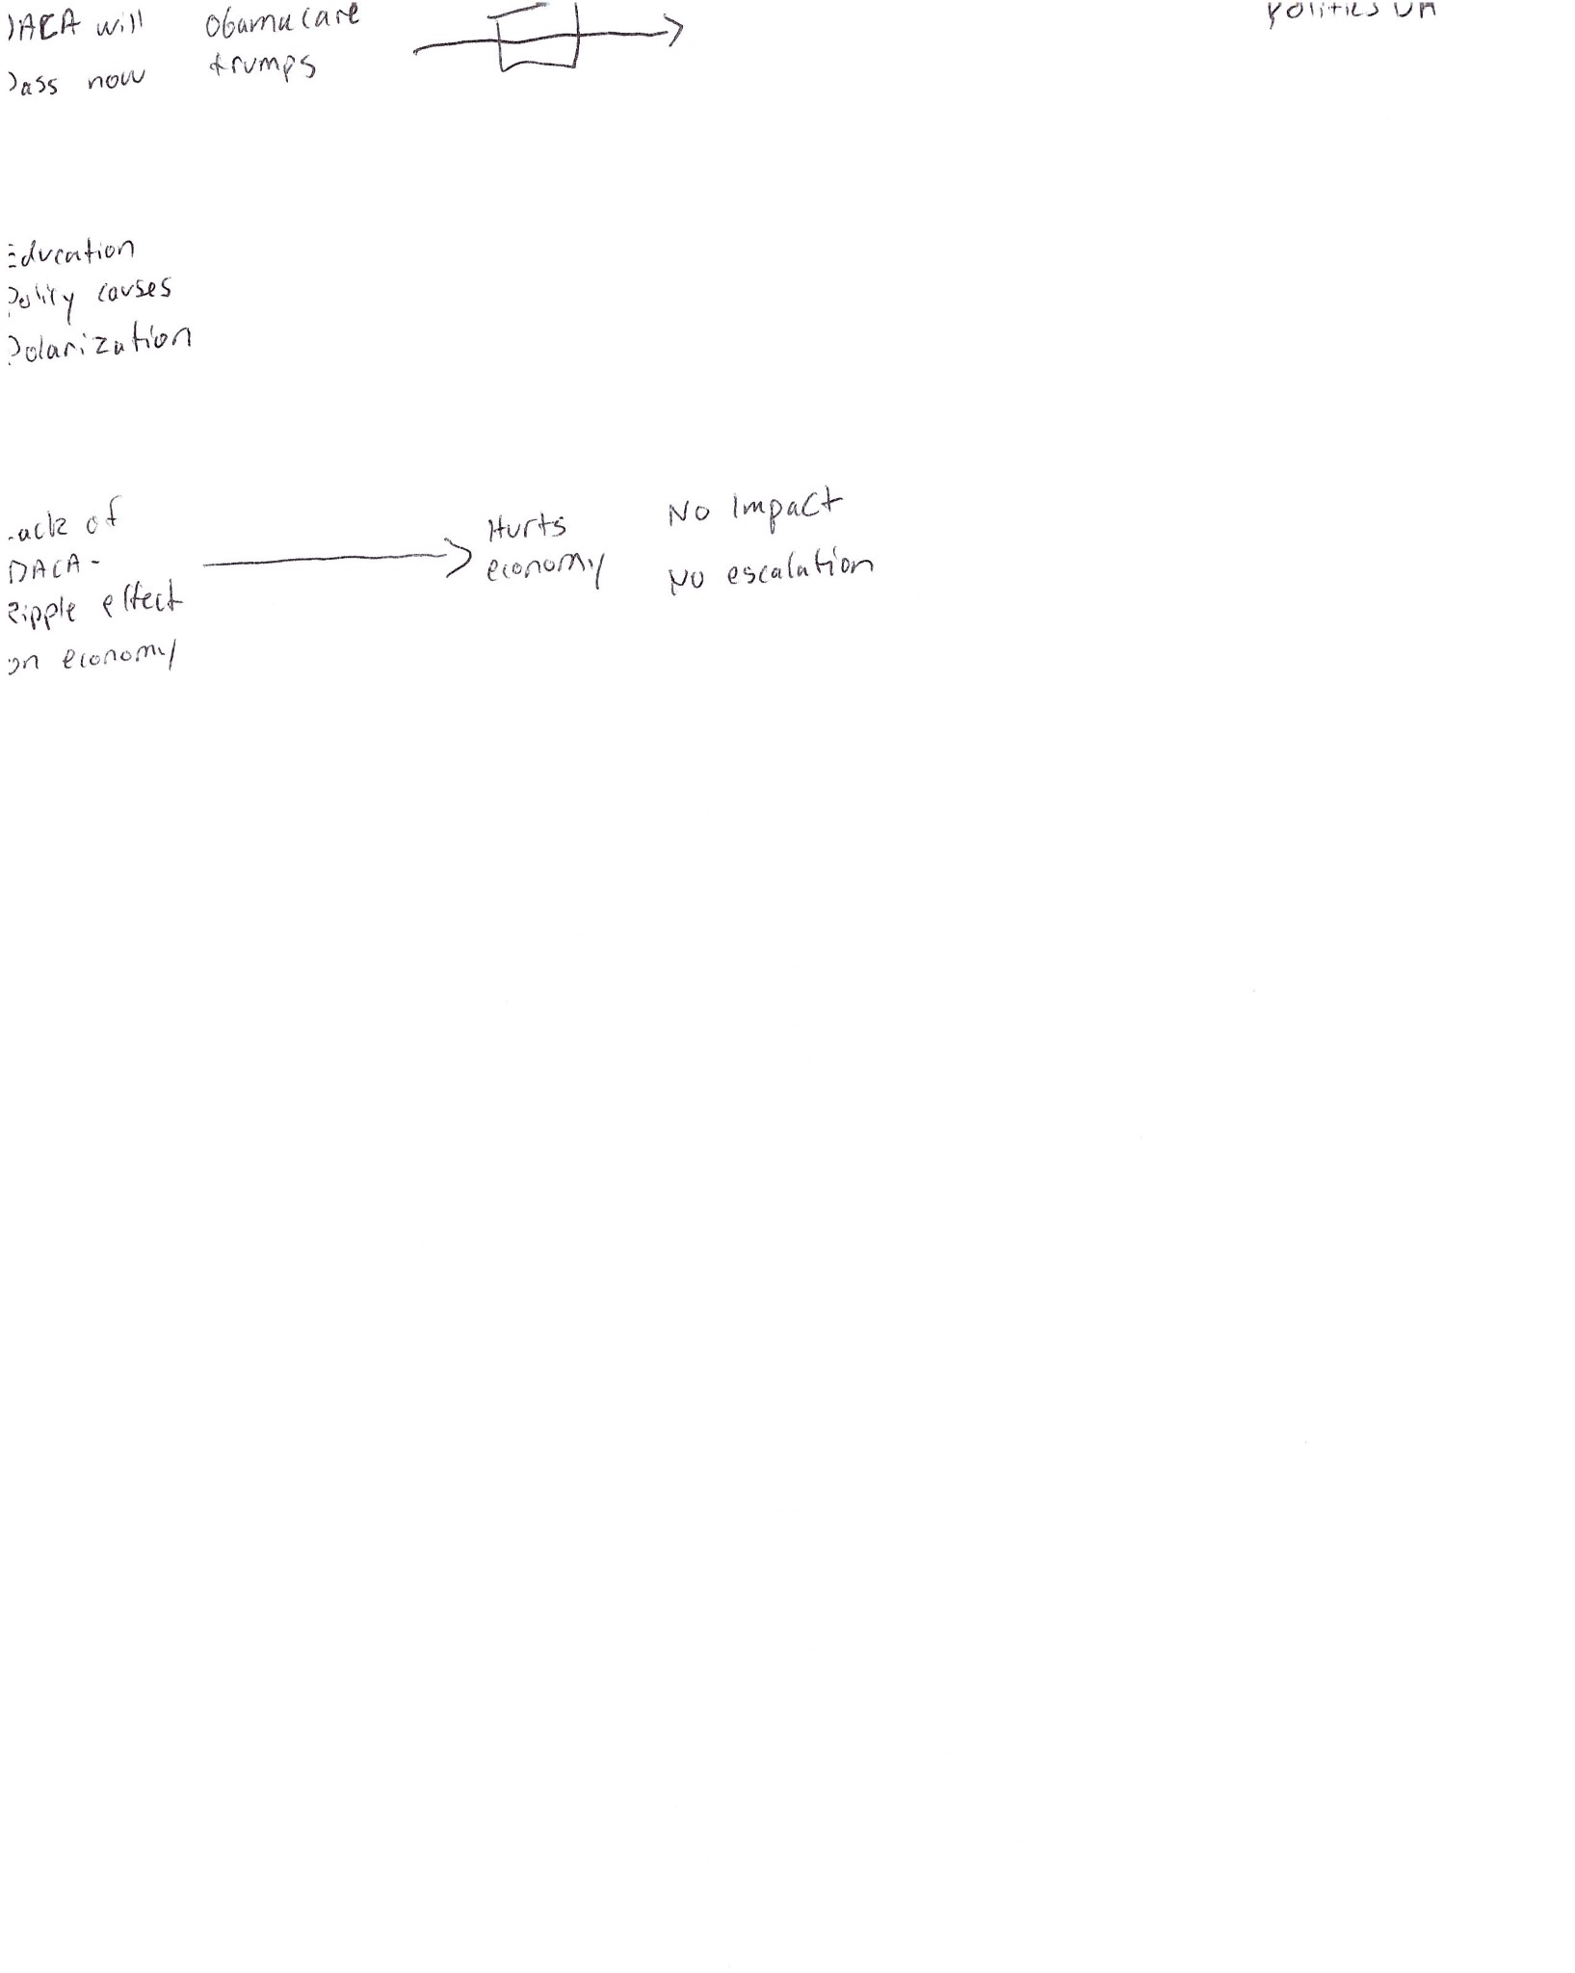

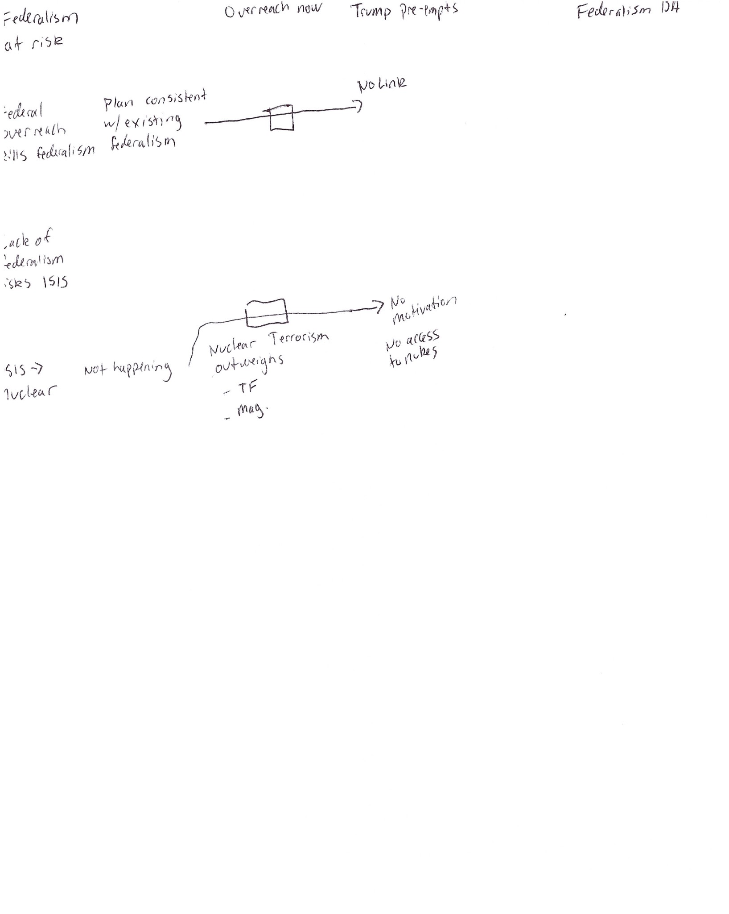

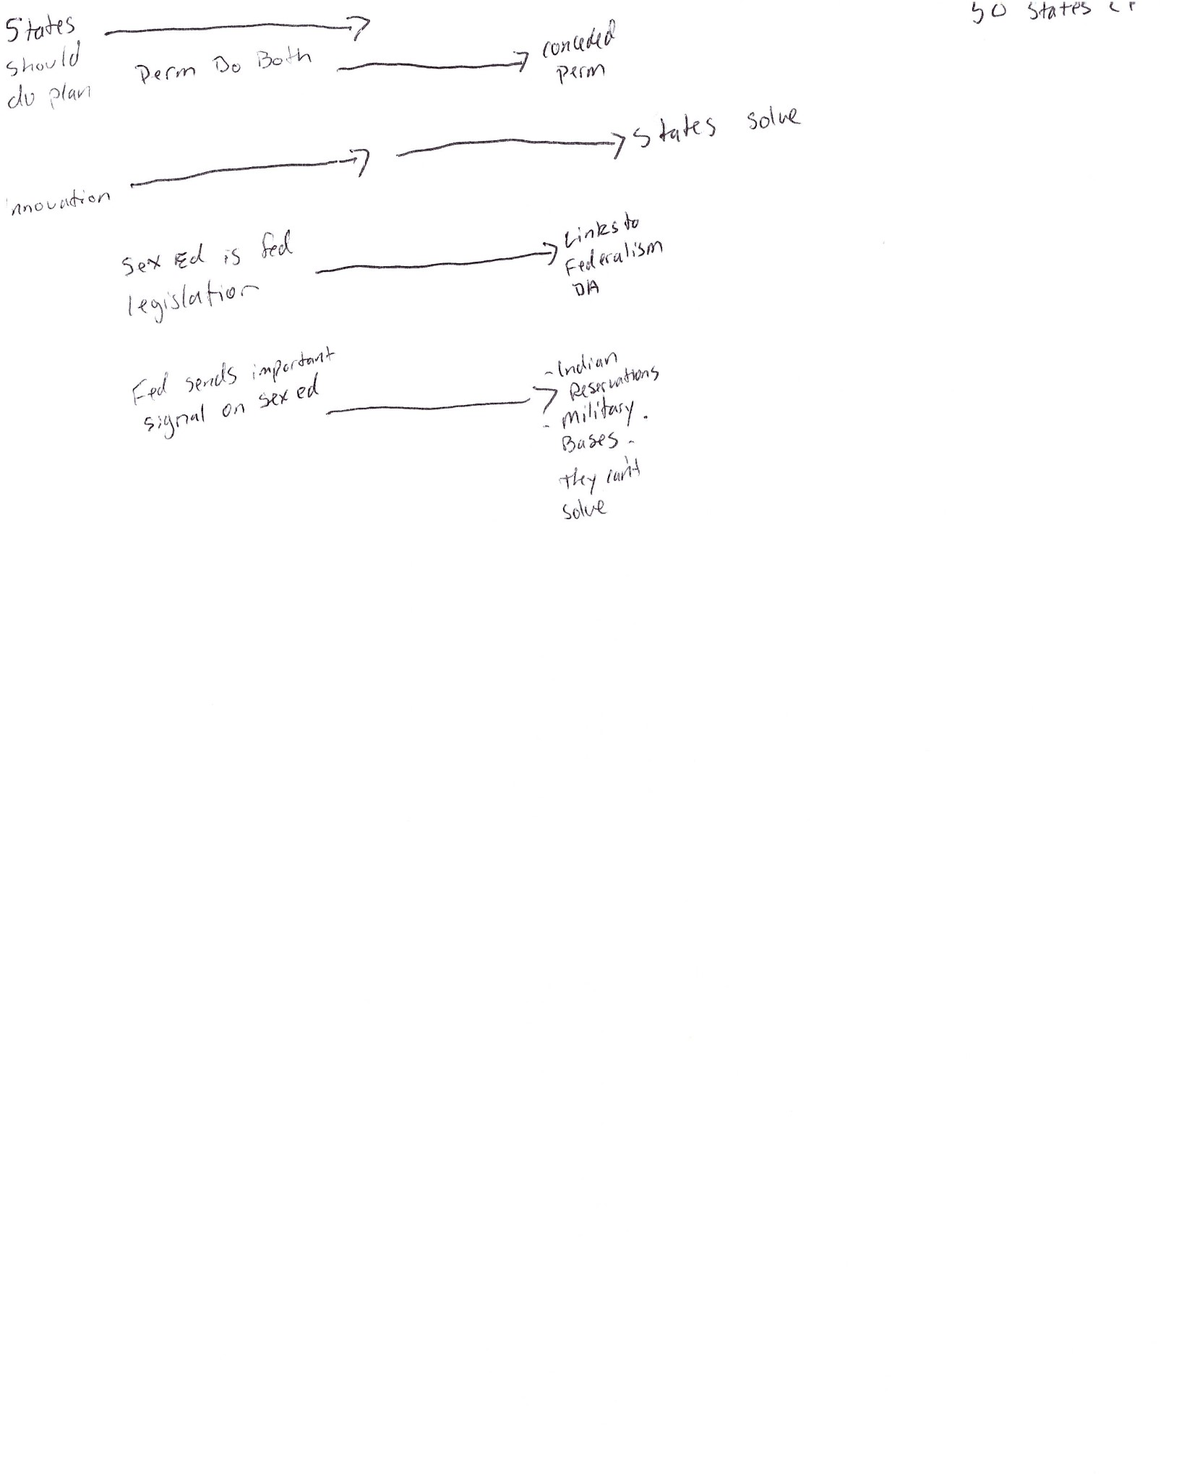

I voted for the affirmative team in this round. The case debate was weak at best and wasn’t extended into the rebuttals. In fact, some of the case debate about AIDS and rape culture probably helped the affirmative case, showing a poor understanding of the 1AC by the negative.

The negative ran 4 off case positions as well.

The first Disadvantage is about the 2018 election, and was an argument the negative went for at the end of the debate. This argument states that the Democrats need the issue of education to run against the Republicans in the 2018 mid-term elections. If we take action on education reform now, the Democrats won’t make gains in 2018, and the Republicans will cause global trade wars.

The affirmative didn’t do a great job answering the argument in the 2AC, but was torn apart in Cross Examination. First, the negative couldn’t answer the question—when is the 2018 midterm election, and when pressed asserted that it was in December….2017. When they couldn’t even name the date of the event they were talking about, it hurt the credibility of everything else they said on the subject. Furthermore, they read evidence that said that the party out of power always makes gains in the mid-term elections, which means that the Disadvantage’s scenario is inevitable. They didn’t have a link specific to sexual education, or make an attempt to tell a story about how the Democrats needed to run on Sex Ed reform. The affirmative team knew more about the Disadvantage than the negative team, and tore them apart even though they didn’t do a great job answering it in the 2AC.

**Lesson:** Don’t run arguments you don’t understand, and don’t attempt to win the round using them.

The second politics Disadvantage discusses DACA, Deferred Action for Childhood Arrivals. DACA is an Obama era policy that allows children who immigrated to this country illegally (as children, so likely not on their own) to stay and work in the U.S. President Trump recently cancelled this policy and threw responsibility for the policy to the Congress, making them take action to provide a path to citizenship or legal status for DACA participants before it runs out in the Spring. This argument suggests a trade-off between education reform and DACA on the political agenda, but wasn’t well thought out. They abandoned this argument quickly.

The Federalism Disadvantage didn’t make a lot of sense. The argument jumped from logical steps about federal over-reach in education policy to nuclear terrorism. The negative was too focused on extending their impact scenario in the Negative Block to bother with the link debate, which they conceded (and lost the argument).

The States Counterplan should be the basis of most negative strategies. Many affirmatives are legitimately better solved by state action, and most policymaking in education is usually done by State governments. As a result, many affirmative cases are generally written to avoid the States Counterplan. This is not one such case. The affirmative did a good job arguing against this States CP. They made a permutation—a “do both” argument, they showed how since Sex ED policy is under the federal government’s jurisdiction now, the Counterplan would unbalance federalism towards the states, linking to the Federalism D.A. They also made a number of arguments about the inability of the counterplan to solve the plan.