WUDL Sample Flow: Varsity

This round features a Pinecrest team against a North Star Academy team. The affirmative argues that inequality in education is everywhere, reinforcing poverty and racism. The second advantage is populism. They argue that increasing education will improve people’s critical thinking skills. This will allow them to see through fake news and resist populists like Donald Trump.

The kritik suggests that African Americans are fed false hope by education reforms which reproduces suffering and harm.

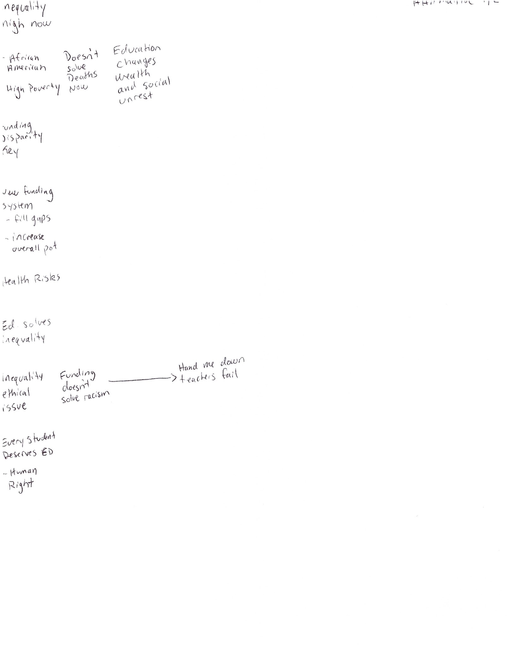

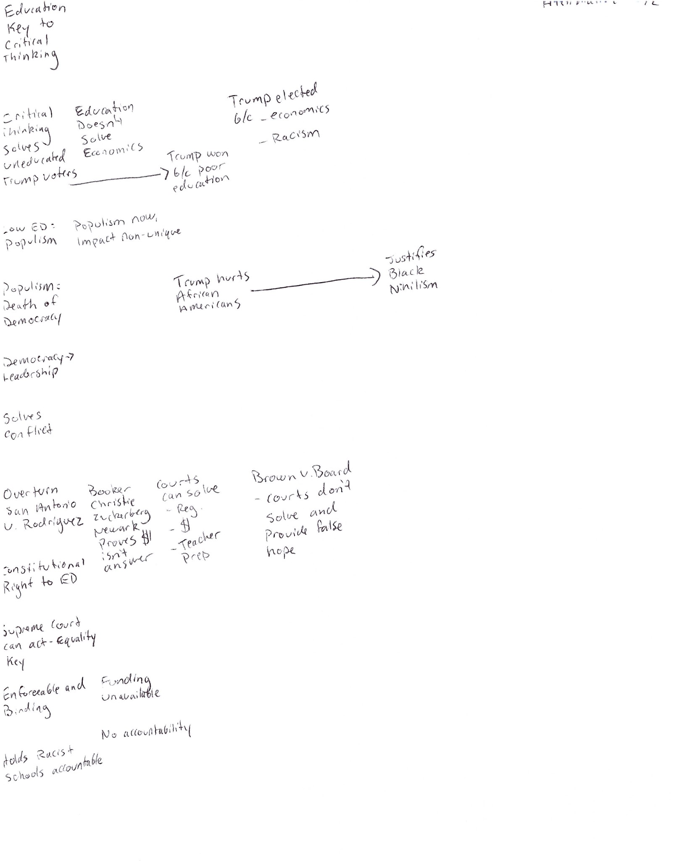

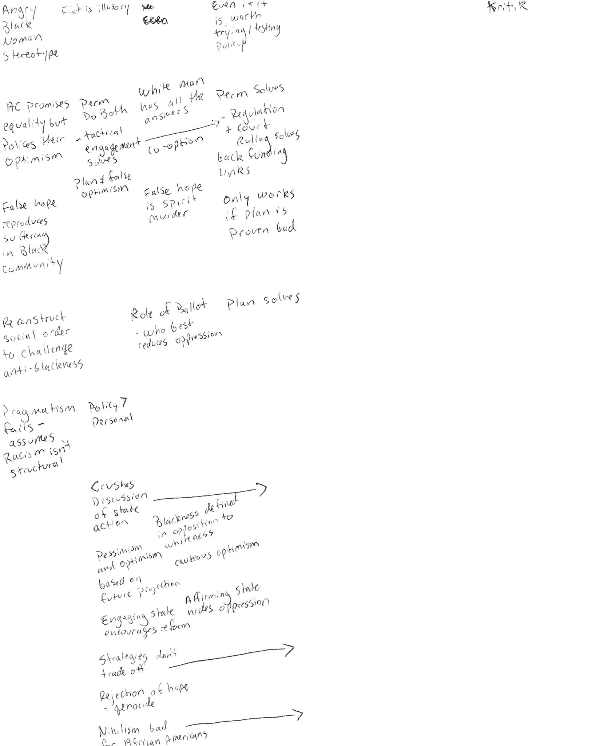

I voted affirmative in this debate.

The rationale is fairly simple, the Kritik is based on the idea that affirmative reforms won’t bring about material change for people of color, thus giving them false hope. The negative therefore must win that the affirmative won’t do anything, aka a no solvency argument. The negative uses examples from Newark that are persuasive but tell an incomplete picture of what happened there. They also don’t have any links to a structural reform like the plan—to overturn a Supreme Court case–San Antonio V Rodriguez, to create a constitutional right to education. The magnitude of the affirmative reform was a compelling argument about why it had a chance to solve. More detailed research about the affirmative and nuanced solvency arguments would have made the difference here. The affirmative case is based on a lot of assumptions about massive behavior change across many years, which would have been a more obvious plan of attack.