WUDL Flowing Sample: Varsity

This flow documents a round between Pinecrest High School (FL) and Thomas Jefferson High School (VA). This round is included in our series for two reasons: To demonstrate how time allocation, especially in the 2AC can determine the outcome of a debate round, and to demonstrate that “Truth” doesn’t always win out over “Tech,” or a very technically proficient team that takes advantage of a mistake.

The affirmative argues that the way that we fund education today—mainly local property taxes, is unfair because it lets rich areas (higher property tax revenues) get better schooling than poorer areas (lower property tax revenues). They propose re-organizing the way we fund schools to be more re-distributive. Exactly how they plan to do that, I’m not entirely sure, but it didn’t turn out to be a defining factor in the round.

The negative team made a few arguments on case, but the majority of their strategy was off-case. They ran a Legalize Marijuana CP (alternate funding mechanism for schools), a Politics DA, an Economy/Inflation DA, and a Feminism Kritik. The 2AC dramatically over-covered one of these off case positions—especially related to how dangerous it was, and lost the round to a very technically proficient and well executed Neg block strategy that I saw coming through CX, but the other team clearly didn’t.

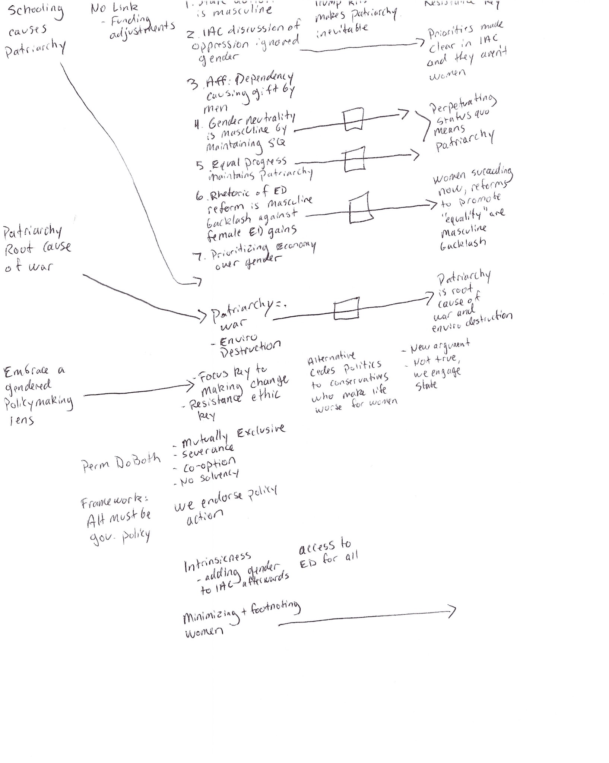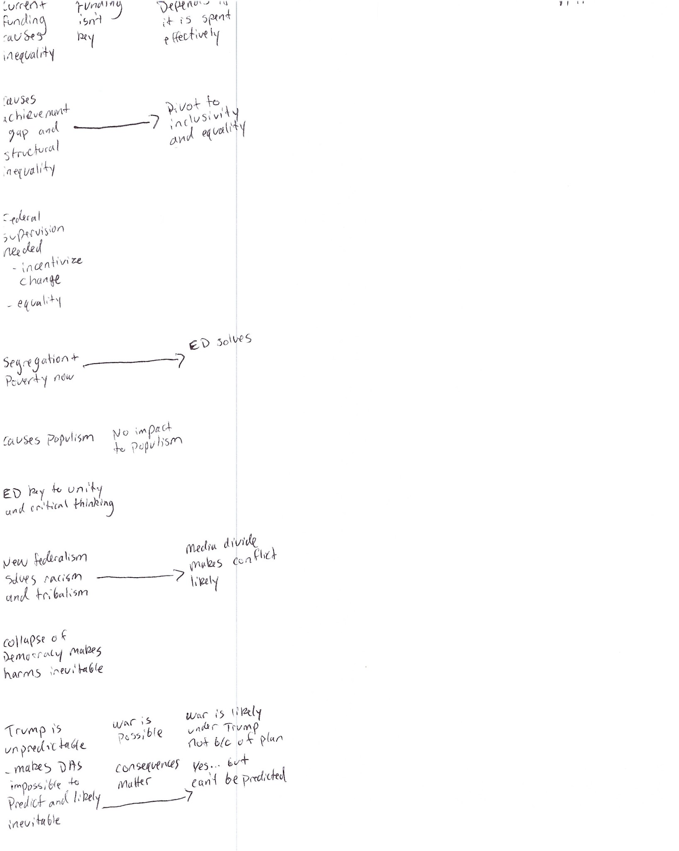

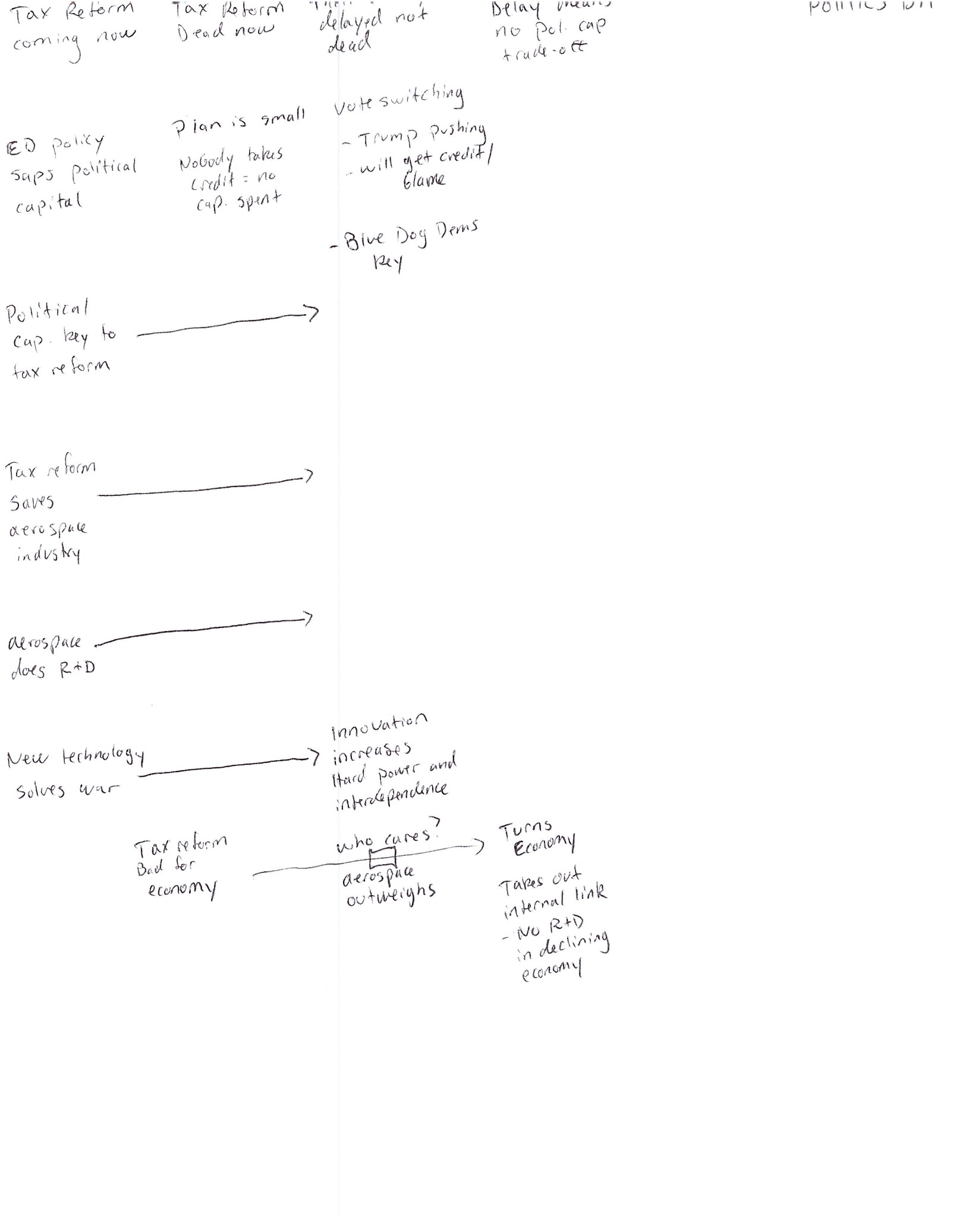

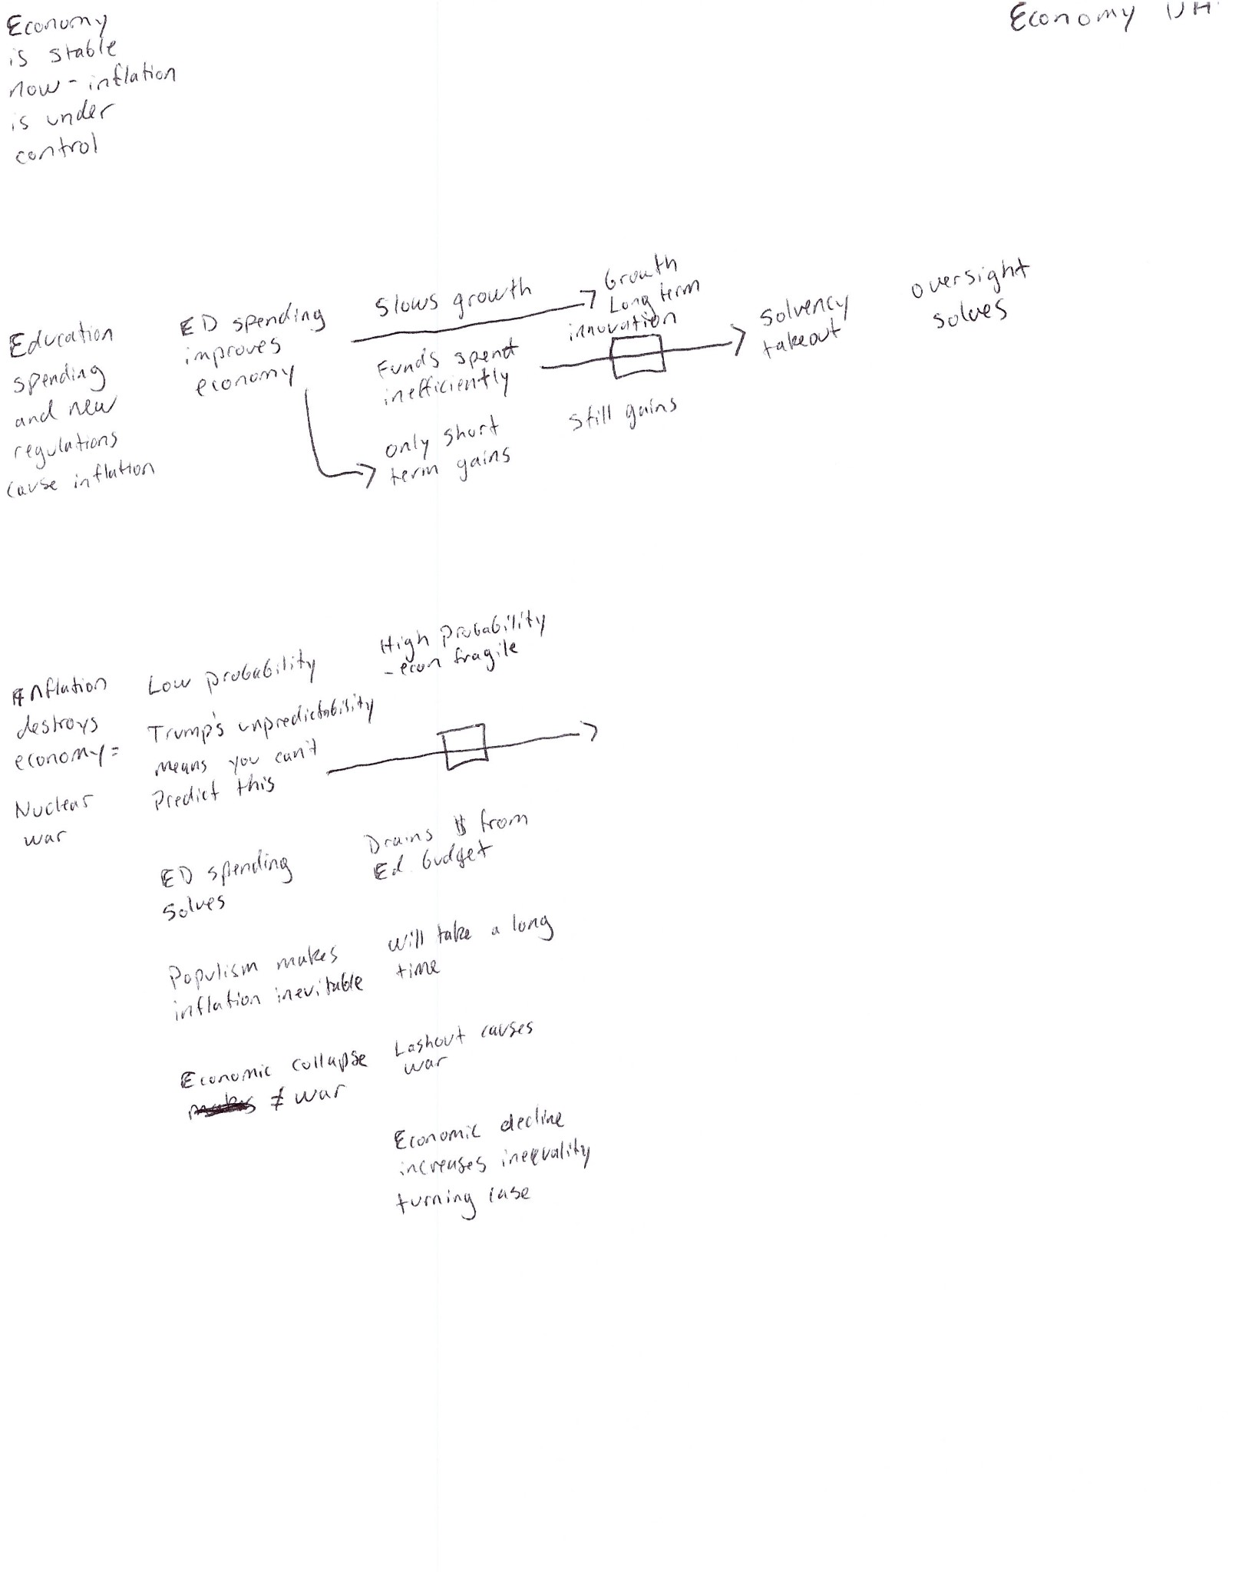

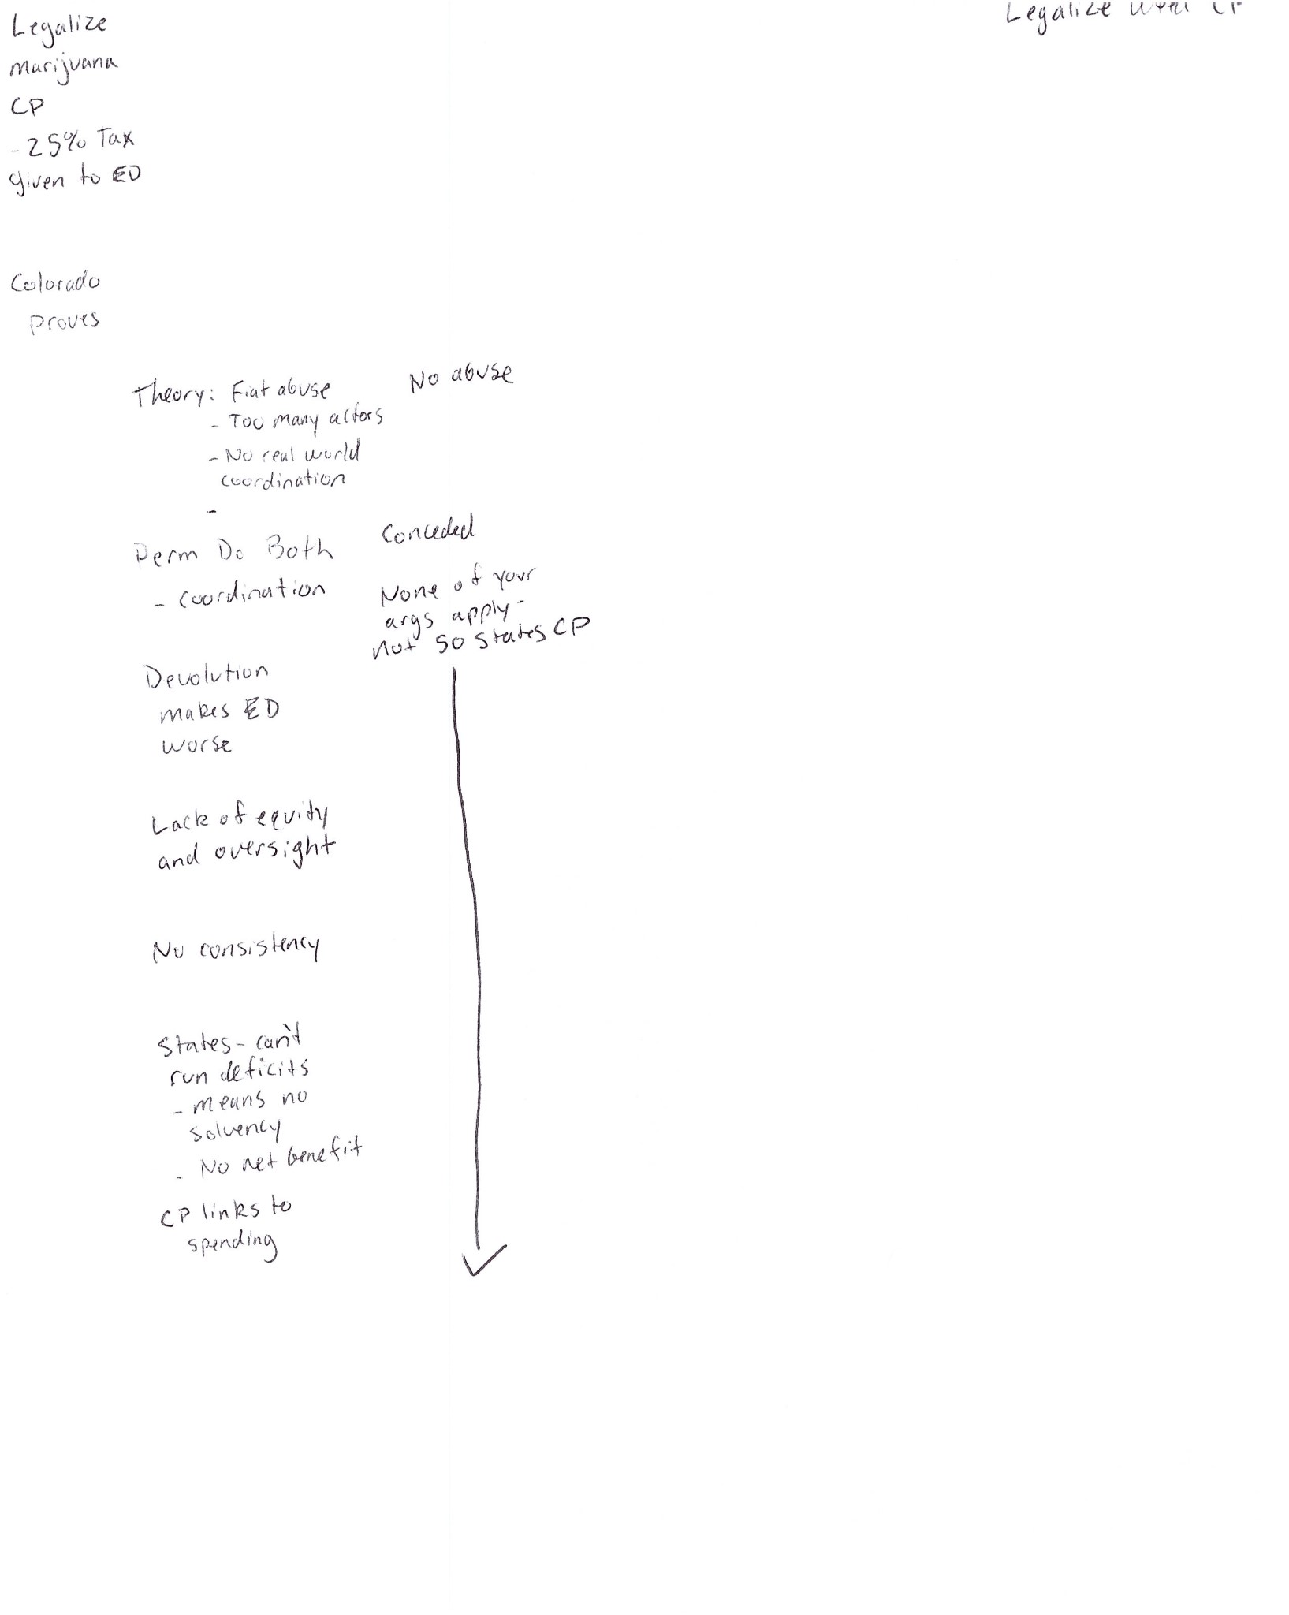

I voted for the negative in this round on the feminism Kritik.

The 2AC dramatically over-covered this Legalize Marijuana CP in the 2AC and didn’t make nearly enough arguments against the Kritik. The Neg Block took advantage of this, and the round was more or less over after that. Speaking to the debaters after the round, they had recently lost to a lot of Counterplans and over-compensated in this debate. While it is important to be responsive to previous loses, don’t go overboard and abandon strategic vision.

In this debate, the Politics DA and the Economy DAs were pulled through the block as distractions, meant to stretch the 1AR thin. They were credible enough threats that they were successful.

The Politics DA was kicked after the Affirmative won a conceded Impact Turn—That tax reform would be bad for the economy, and that economic stress would reduce funding available to schools.

Notice how they kicked it properly—the affirmative team made offensive arguments against the DA, and the negative had to extend and concede a uniqueness argument (defensive) to escape the turn.

The Economy DA is very generic, but works against a large, systemic affirmative like this case. It argues that education spending is a very poor use of public funds, resulting in inflation and hurting the economy. There was a robust link debate, but it could have used a little more contextualization to the plan itself instead of just being generic Econ DA answers.

The Feminism Kritik is where the debate is very interesting. Notice that the 1NC shell is very generic and unassuming—3 cards, none are particularly case specific or menacing. A generic argument about schooling being gendered, and “the patriarchy” being the root cause of all violence and war.

Unfortunately for the Affirmative, they fell for the bait, making minimal arguments on this flow. The 2NC made a very good show of executing a Kritik. First, they dropped an impressive “link wall” at least 7 distinct arguments deep, adding nuance where needed to the specifics of the 1AC. Next, they extended the conceded impact scenario, AND added a new impact about environmental destruction. Lastly, they explained their alternative, and made sure to answer the minimal 2AC arguments. They just buried an unprepared affirmative team, winning a significant time trade-off.